ELEMENTARY SCHOOL MEALS PROGRAM
LUNCH ORDER FORM

School’s Name:
Student’s Name:
Grade:
Division:
Teacher:

Allergies / Religious Requests:
- Vegetarian/Fish OK □ Vegetarian/No Fish
- No Pork
- Other: _____________________________________________________

Payment Amount: _______________



May 2019

MONDAY | TUESDAY | WEDNESDAY | THURSDAY | FRIDAY
 | 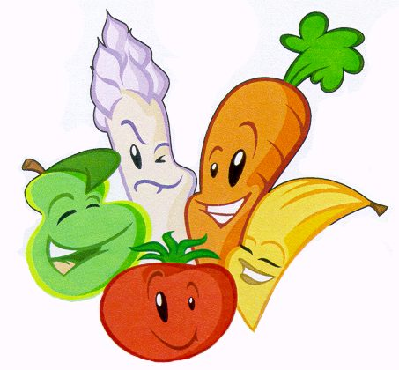 | 1  Chocolate Milk  Bagel & Cream Cheese  Veggie & Dip  Fruit | 2  Juice  Egg Sandwich  Yogurt  Fruit | 3  White Milk  Cheese Sandwich  Cookie  Fruit
6  Juice  Roast Beef Sandwich  Yogurt  Fruit | 7  Chocolate Milk  Ham Sandwich  Granola Bar  Fruit | 8  Juice  Pizza Wrap  Pudding  Fruit | 9  White Milk  Turkey Sandwich  Rice Krispie  Fruit | 10  Juice  Cheese Sandwich  Yogurt  Fruit
13  Chocolate Milk  Roast Beef Sandwich  Cookie  Fruit | 14  Juice  Tuna Sandwich  Yogurt  Fruit | 15  White Milk  Ham Sandwich  Bits & Bites  Fruit | 16  Juice  Turkey Sandwich  Yogurt  Fruit | 17  Chocolate Milk  Cheese Sandwich  Cookie  Fruit
20  Victoria  Day | 21  Juice  Rosat Beef Sandwich  Pudding  Fruit | 22  White Milk  Cucumber/Cheese Sandwich  Granola Bar  Fruit | 23  Juice  Egg Sandwich  Yogurt  Fruit | 24  Chocolate Milk  Cheese Sandwich  Chips  Veggie & Dip
27  Juice  Roast Beef Sandwich  Yogurt  Fruit | 30  White Milk  Ham Sandwich  Granola Bar  Fruit | 29  Juice  Bagel & Cream Cheese  Pudding  Fruit | 30  Chocolate Milk  Turkey Sandwich  Chips  Fruit | 31  Juice  Cheese Sandwich  Yogurt  Fruit
PLEASE NOTE:

- WE DO NOT GUARANTEE A NUT-FREE ENVIRONMENT. ALL OF OUR BREADS AND BAKED GOODS
MAY CONTAIN TRACES OF NUTS.

- MENU SUBJECT TO CHANGE BASED ON AVAILABILITY FROM SUPPLIERS.

- April 2019 Lunches: 22 @ $5.50 = $121.00
- Please pay with your (KEV) school cash on-line account.

- ORDER DUE TO OFFICE BY 9:00 AM, TUESDAY APRIL 23, 2019 – SORRY, LATE ORDERS WILL NOT BE ACCEPTED.

